

Inventory Management System Project
Course: Introduction to Computing Science II
Instructor: Dr. Mehak Khurana
Semester: Fall 2025-2026

NAME OF STUDENT | STUDENT ID
Borna Hasanzadeh | 20240005688
Mohammad Nader GhasemiFard | 20240005892
Kamyar Bakhshizadeh | 20240005258
Omar Khoori | 20240005576

Problem Statement
While doing our project we faced multiple errors which made us realize how hard it is to manage inventory manually. First problem we faced was when we were adding a product with the same ID, instead of showing an error it was adding the product. So when we would search for the ID it would only show the first product and not the second. This made us realize that there’s an error in our code when we were in Phase 3, testing the code.
Another problem we faced was when for example we were adding a product, we were adding the id and the name and in the middle we decided to cancel and not add the product, we didn’t have an option for that.

Objectives
Make a simple Java program that helps keep track of products in a store.
Create separate classes so everything is organized and easy to manage.
Let the user do basic actions like add, view, update, delete, and search for products.
Use exception handling so the program doesn’t crash when someone enters something wrong.
Test everything to make sure all the menu options work the right way.
Make the program easy to improve later.

Java Code

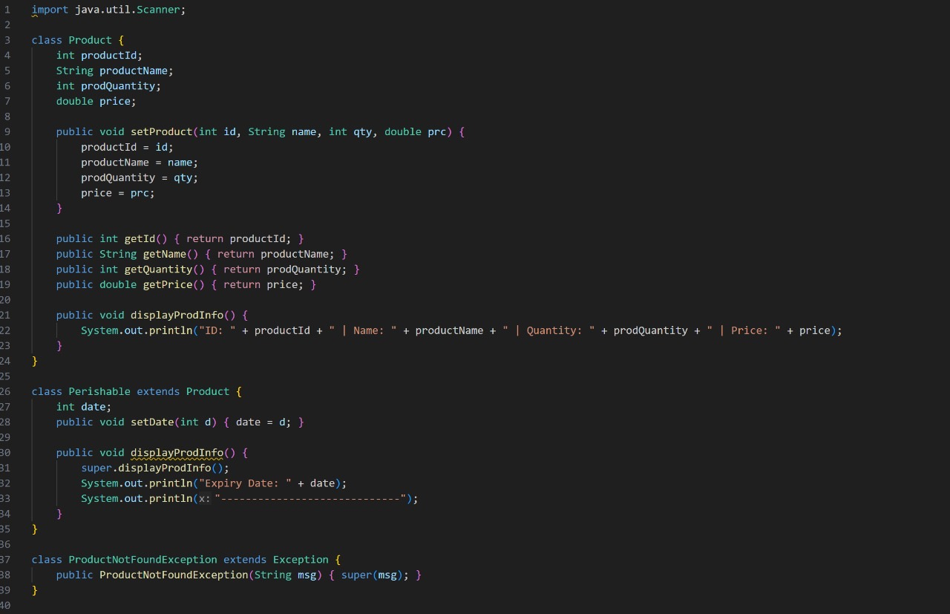

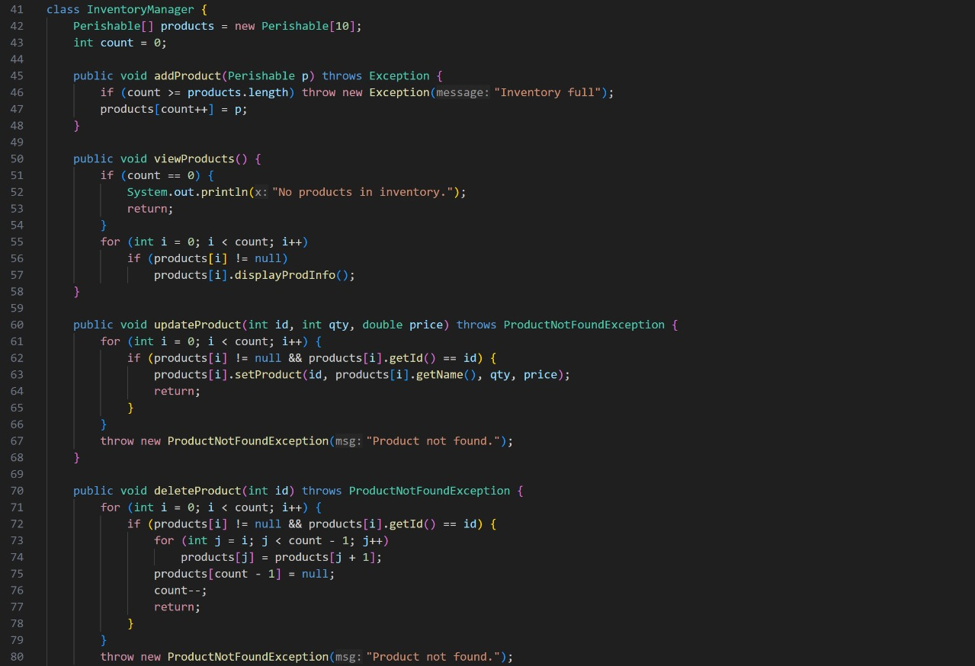

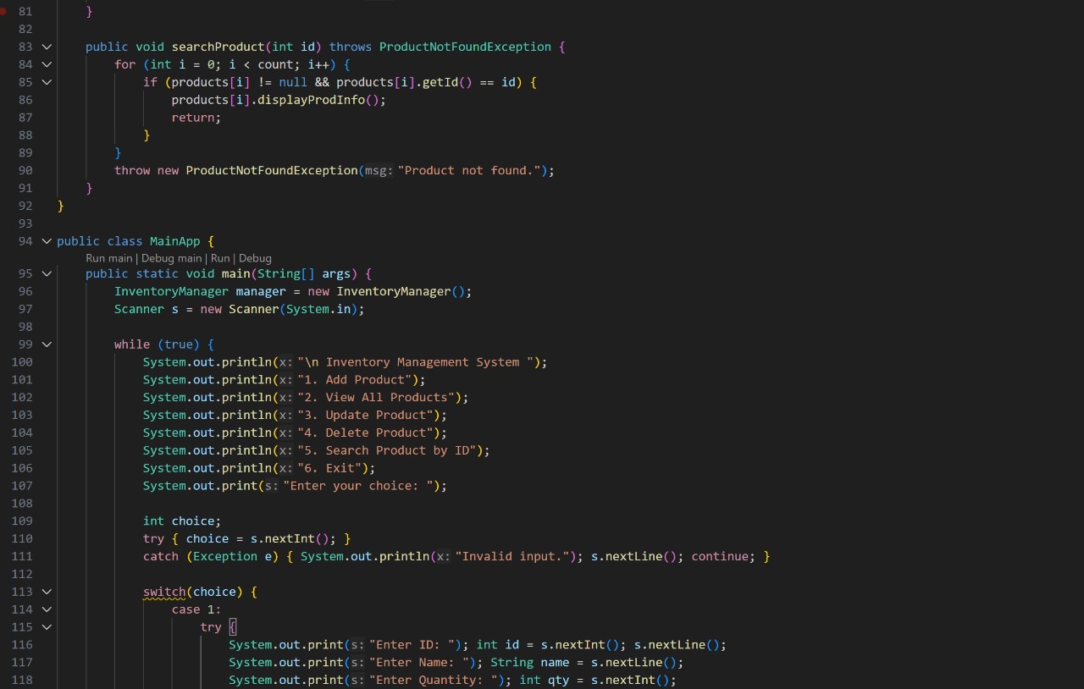

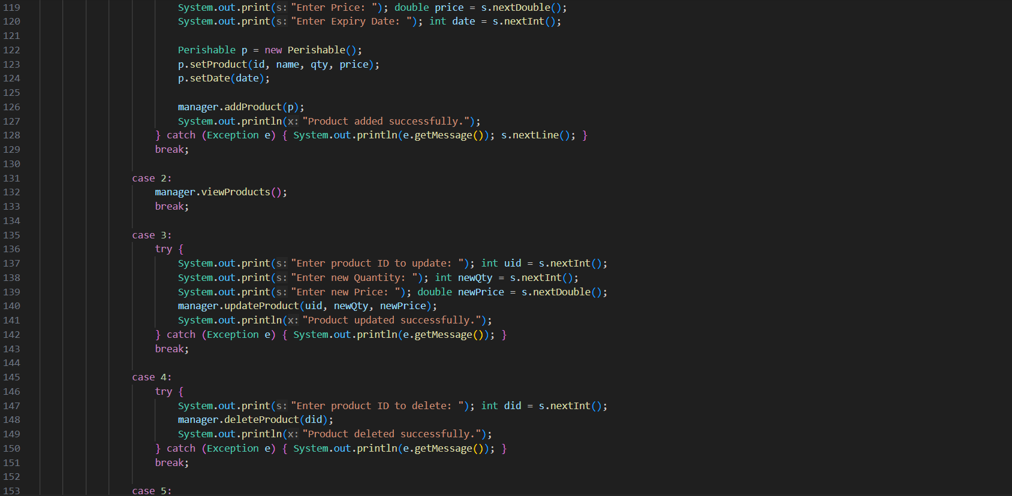

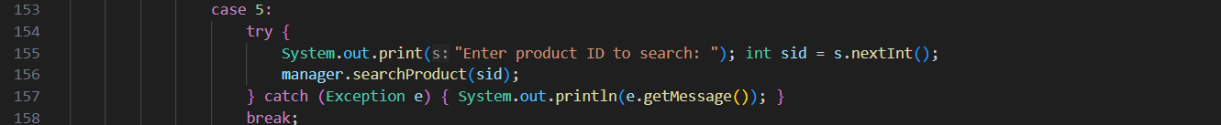

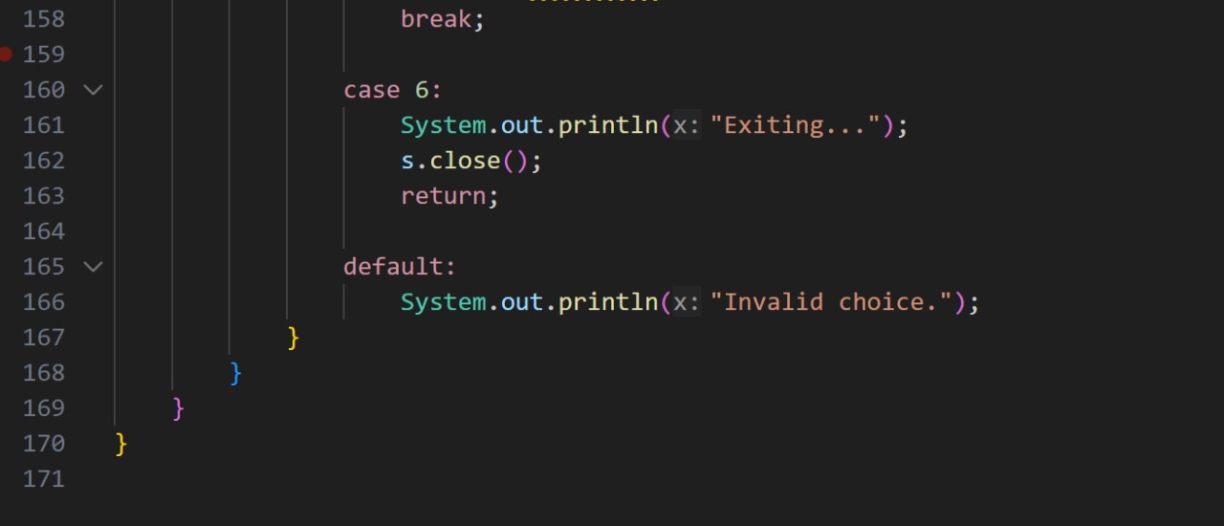

Results & Output
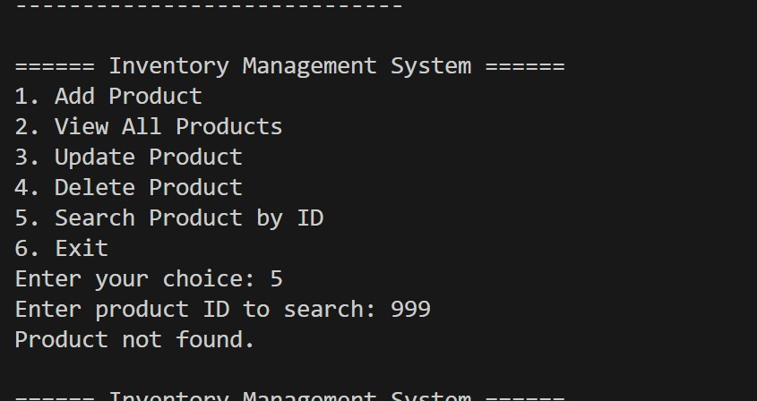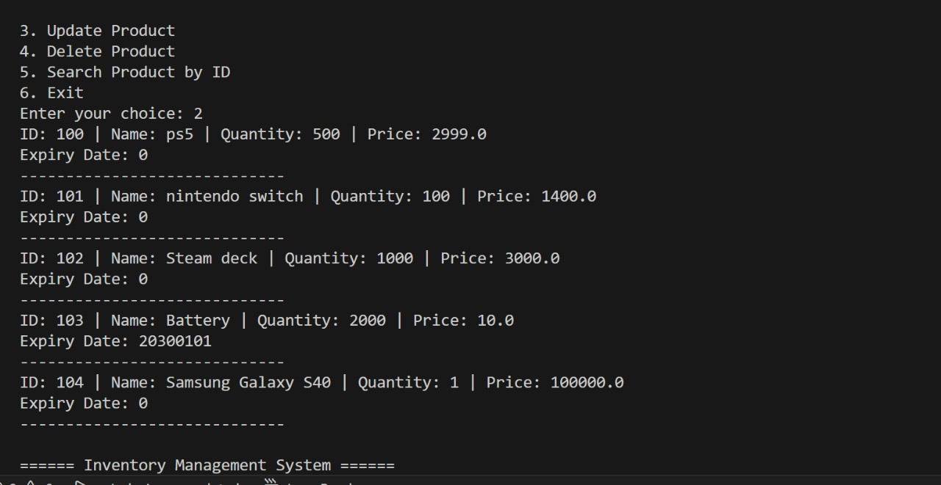

Class Diagram

Marks Distribution and Marking Criteria

Sno. | Section | CLO | Max Marks | Marks Obtained
Compare appropriate computing principles to propose viable solutions.

Module 1 –  Evaluate Java applications by examining exception handling and adherence to object-oriented principles. |  |  | 5
 | Design application adhering OOPs principles | CLO3 | 2.5
 | Testing the application | CLO3 | 2.5
Module 2 – Apply structured solutions to computational challenges by employing advanced programming constructs and design principles |  |  | 5
 | Core OOPs Functionality & inheritance, Exception Handling etc | CLO4 | 2.5
 | Apply Advanced features, Possible future extensions | CLO4 | 2.5
 | Total |  | 10

Section / Criteria | Exceeds Standards | Meets Standards | Partially Meets Standards | Unsatisfactory
Module 1 – Design & Testing (5 Marks Total)
1. Design application adhering to OOP principles (2.5 Marks) | 2.5 – Classes designed with correct inheritance, encapsulation, overriding; modular, clean code; reusable and maintainable. | 2 – Classes designed with correct inheritance and basic OOP principles; code runs correctly. | 1 – Classes partially follow OOP principles; some methods or inheritance missing; minor errors. | 0 – Classes poorly designed or missing; OOP principles not applied; code does not run.
2. Testing the application (2.5 Marks) | 2.5 – Comprehensive test cases (>5) covering normal, boundary, and invalid inputs; all outputs correct; exceptions handled robustly. | 2 – At least 5 test cases covering normal and some invalid inputs; most outputs correct; exceptions handled. | 1 – Fewer than 5 test cases; limited coverage; some outputs incorrect; partial exception handling. | 0 – No meaningful test cases; outputs mostly incorrect; exceptions not handled.
Module 2 – Core Functionality & Advanced Features (5 Marks Total)
3. Core OOP Functionality & inheritance, Exception Handling (2.5 Marks) | 2.5 – All menu options implemented correctly; modular methods; robust exception handling; program stable under all inputs. | 2 – All menu options implemented; methods mostly modular; exception handling present; minor issues. | 1 – Some menu options missing; modularity limited; exception handling partially applied. | 0 – Menu options missing or non-functional; poor structure; program crashes on invalid input.
4. Apply Advanced features, Possible future extensions (2.5 Marks) | 2.5 – Advanced features implemented (expiry date, sorting, etc.); reflection on future improvements; code highly maintainable and well-structured. | 2 – Optional features implemented; basic reflection on future improvements; code mostly maintainable. | 1 – Minimal optional features; reflection limited; code partially maintainable. | 0 – No optional features; no reflection; code poorly structured.

